 | 10.1.16 Editors - Compositor Editor - Header - Add Menu - Utilities - Vector
Table of content
Detailed table of content 1
Add menu - Utilities - Vector 4
Combine XYZ 4
Map Range 4
Mix Vector 5
Separate XYZ 6
Radial Tiling 7
Vector Curves 7
Vector Math 9
Vector Rotate 9

Detailed table of content
Detailed table of content
Detailed table of content 1
Add menu - Utilities - Vector 4
Combine XYZ 4
Input 4
X Y and Z 4
Output 4
Color 4
Map Range 4
Usage 4
Inputs 4
Vector 4
From Min/Max 5
To Min/Max 5
Steps 5
Properties 5
Data Type 5
Interpolation Type 5
Clamp 5
Outputs 5
vector 5
Mix Vector 5
Inputs 5
Factor 5
Value A 5
Value B 6
Properties 6
Data Type 6
Factor Mode 6
Clamp Factor 6
Outputs 6
Result 6
Separate XYZ 6
Input 6
Vector 6
Output 6
X, Y and Z 6
Radial Tiling 7
Input 7
Vector 7
Sides 7
Roundness 7
Properties 7
Normalize 7
Vector Curves 7
Inputs 7
Vector 7
Properties 7
Channel 7
Channel buttons 7
Curve edit field 7
Selecting Points 8
Adding Points 8
Zoom in and out 8
Clipping options 8
Tools 8
Reset View 8
Extend horizontal 8
Extend extrapolated 8
Reset Curve 8
Vector Handle 8
Auto Handle 8
Auto Clamped Handle 8
X / Y position 8
Delete Points 9
Outputs 9
Vector 9
Vector Math 9
Inputs 9
Vector 9
Vector 9
Properties 9
Operation 9
Outputs 9
Value 9
Vector Rotate 9
Inputs 9
Vector 9
Center 10
Axis 10
Angle 10
Properties 10
Type 10
Invert 10
Outputs 10
Vector 10

Add menu - Utilities - Vector

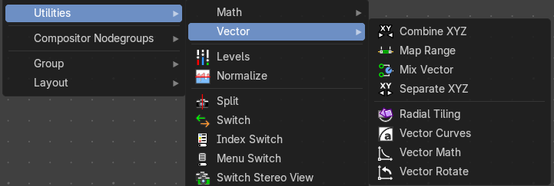
Here you find mainly nodes for vector data manipulation.

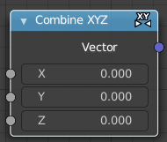
Combine XYZ
Same as with Combine RGB node. It combines color values. But instead combining rgb values, which are in the range of 0 to 255, it uses values in the range from 0 to 1.

Input

X Y and Z
X, Y and Z values.

Output

Color
Color output.

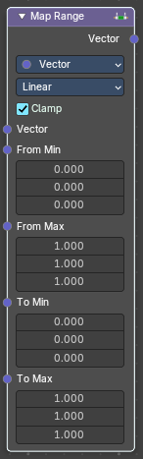
Map Range
This node allows to convert (map) an input value range into a destination range. By default, values outside the specified input range will be proportionally mapped as well. This node is similar to Map Value node but provides a more intuitive way to specify the desired output range.

Usage
One important use case is to easily map the original range of the Z-depth channel to a more usable range (i.e: 0.0 - 1.0) for use as a matte for colorization or filtering operations.

Inputs
This chapter deals with the input type Float. The same node exists in the Math menu too. With preselected type Float.

Vector
Standard vector input.

From Min/Max
Vector 3 of the Start/End of the input value range.

To Min/Max
Vector 3 of the Start/End of the destination range.

Steps
The amount of steps.
Note: Only shows when using the Stepped Linear interpolation type.

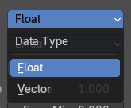
Properties

Data Type
Selects between float or vector values to map the range.

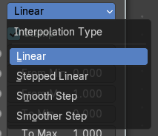
Interpolation Type
Selects between a linear, stepped linear, smooth step or smoother step interpolation types.

Clamp
Clamps values to Min/Max of the destination range.

Outputs

vector
Standard value output.

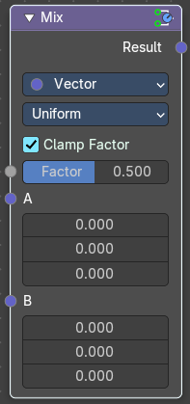
Mix Vector
The Mix Vector node blends two vector inputs using a specified factor. It’s useful for compositing tasks that involve motion vectors, directional effects, or spatial blending, offering precise control over how two sets of vector data are combined

Inputs

Factor
Controls the amount of influence the node exerts on the output result.

Value A
The back value.

Value B
The top value.

Properties

Data Type
Set to Vector, indicating the node mixes vector values.

Factor Mode
The method of mixing.
- Uniform: A single float controls the mix across all vector components.
- Non-Uniform: A vector input controls the mix per component (X, Y, Z).

Clamp Factor
Limit the highest color value to not exceed 1.

Outputs

Result
Vector output.

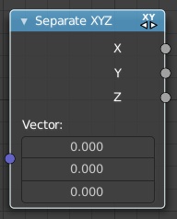
Separate XYZ
Same as with Separate RGB node. It separates color values. But instead separating rgb values, which are in the range of 0 to 255, it uses a vector with the values in the range from 0 to 1.

Input

Vector
The Input vector.

Output

X, Y and Z
The output vectors for X, Y and Z

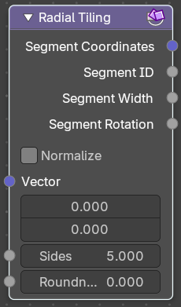
Radial Tiling
Transform coordinate system for radial tiling.

Input

Vector
Vector 2 input

Sides
Number of angular segments for tiling. A non integer value results in an irrgeluar segment.

Roundness
Roundness of the segment coordindates system.

Properties

Normalize
Normalize the X coordinate of the segment coordinates output to a [ 0 / 1 ] interval and offset the Y coordinate into a [0, infinity] interval. This stretches the textures to fit into each angular segment. Else they are cropped.

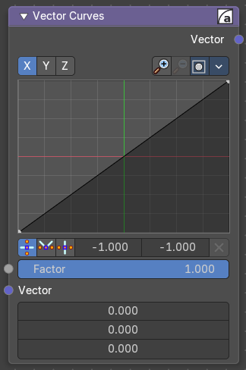
Vector Curves
The Vector Curves node maps an input vector components to a curve.

Inputs
In the shader context the node also has an additional Factor property.

Vector
Standard vector 3 input.

Properties

Channel

Channel buttons
X, Y, Z. Clicking on one of the channels displays the curve for each.

Curve edit field
Create and tweak a Bezier curve that varies the input levels (X axis) to produce an output level (Y axis).


Selecting Points
You can select curve points. This reveals two edit boxes for the x and y coordinate of this point.
Selected points can be moved around. Left click at them, hold the mouse button down and move them to a new location.


Adding Points
You can add new curve points by simply left clicking at the curve. Move the mouse to position them where you need it.

Zoom in and out
The two buttons with the magnifying glass at it zooms in and out in the curve window.


Clipping options
Clipping options. Set up clipping for the stroke.

Tools
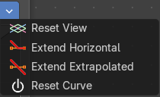
Tools is a menu where you can find some curve related tools.

Reset View
Resets the curve windows zoom.

Extend horizontal
Extends the curve before the first curve point and behind the last curve point horizontally.

Extend extrapolated
Extends the curve before the first curve point and behind the last curve point extrapolated.

Reset Curve
Resets the curve to the initial shape.

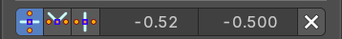
Vector Handle
Set handle type to Vector.

Auto Handle
Set handle type to Auto.

Auto Clamped Handle
Set handle type to Auto Clamped.

X / Y position
The x y coordinate of the selected curve point. The range goes from -1 to +1

Delete Points
Deletes selected curve points.

Outputs

Vector
Standard vector 3 output.

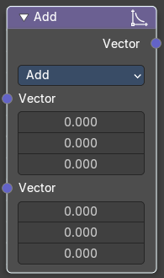
Vector Math
The Vector Math Node performs math operations.

Inputs

Vector
First numerical value. The trigonometric functions accept values in radians.

Vector
Second numerical value. This value is not used in functions that accept only one parameter like the trigonometric functions, Round and Absolute.

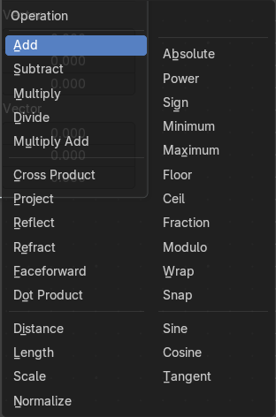
Properties

Operation
Here you can choose what mathematical operation to perform.

Outputs

Value
Numerical value output.

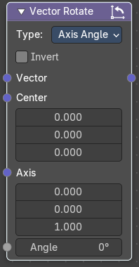
Vector Rotate
The Vector Rotate node rotates a vector around a specified axis and center point. It’s useful for compositing tasks involving directional transformations, such as rotating motion vectors, normals, or custom vector fields

Inputs

Vector
The input vector to be rotated.

Center
The pivot point around which the vector is rotated.

Axis
The axis of rotation, defined as am XYZ based 3D vector

Angle
The amount of rotation in degrees.

Properties

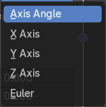
Type
Determines the rotation method.
- Axis Angle: Rotates around a custom axis by a specified angle.
- X/Y/Z Axis: Rotates the vector around the X/Y/Z-axis.
- Euler: Applies rotation using Euler angles in XYZ order.

Invert
When enabled, reverses the direction of the rotation.

Outputs

Vector
The rotated vector result.

